S.2
History and Political Education
Paper 1
2024
July/August
2 ¼ hours

BSR JOINT ASSESSMENT
2024

UGANDA CERTIFICATE OF EDUCATION

HISTORY AND POLITICAL EDUCATION

PAPER 1 FOR S.2

2 HOURS 15 MINUTES

INSTRUCTIONS

- Attempt only three (3) scenarios

Turn over
Scenario 1:
Learners of S.1 were given a task to make research about Uganda Martyrs and present their findings in class the following week. However, many senior ones were confused and didn’t know what to do since many of them had never made research before. They came to you as a senior two student to help advise them on what and to do especially that they are in a school environment

Support material
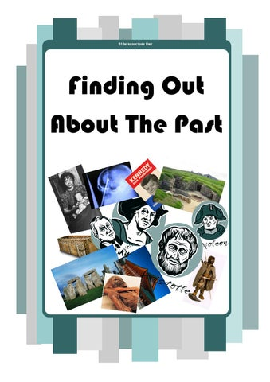

DJE Learning and Training, Jun 27, 2013: Finding Out About the Past
Task:
Write an essay advising the S.1 learners
Scenario 2:
The chairperson of Mengo Kisenyi organised a meeting to consult community members on what to do with the Somalis that he thinks have increased insecurity and drug abuse in the area. Almost 90% of the community members suggested the expulsion of Somalis from the community which the chairperson accepted. However, one old Muzeeyi opposed them arguing that none of those people that wanted to expel Somalis was a true Uganda. All local members denounced him and gave him only two days to provide evidence of his claim or else, he leaves the village together with the Somalis. The Muzeeyi is left with only six hours but still has insufficient information. He has come to you for more information.
Support material
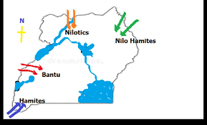
Task:
Write an essay containing information that can save him
Scenario 3
In a drive to promote industrial growth, the government has come up with a project of constructing a very big juice making factory in your local area which if completed will employ over 500 people and also provide market to locally produced fruits. Unfortunately, the site located is too important to the local community as they believe it was the home of their ancestor who lived 2000 years ago. The government insist this is the best site for the factory whereas cultural leaders insist they can’t destroy the house of their ancestor because of a mere factory. The cultural leaders want a person who can help them convince the government get another site. You have been identified and sent to go and convince the government to ignore the site.
Support material
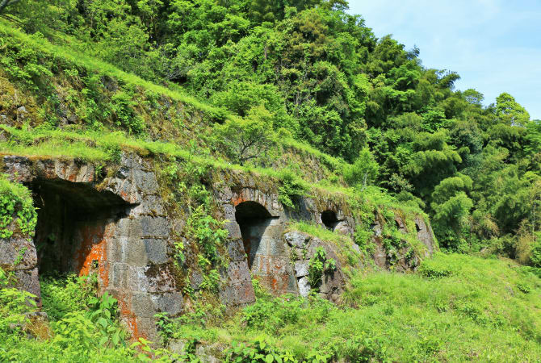
One of the world heritage sites that have been kept well in Japan
Task:
Write an essay of your presentation
Scenario 3:
A certain lady got a man last year and the two have been intending to get married this year. Unfortunately, the lady found out that the man has a religion she doesn’t understand. The man doesn’t go to any church neither a mosque but instead goes to a local shrine every Wednesday of the week and they pray traditionally there. She politely told the man to stop his paganism. The man felt offended and stopped talking to her not until she apologised for calling him pagan. The lady talked to her brother about the paganism of her man. Her brother shocked her by responding that her man was not a pagan but instead, a highly religious man. The lady was not convinced with this statement and came to you for more advice
Support Material
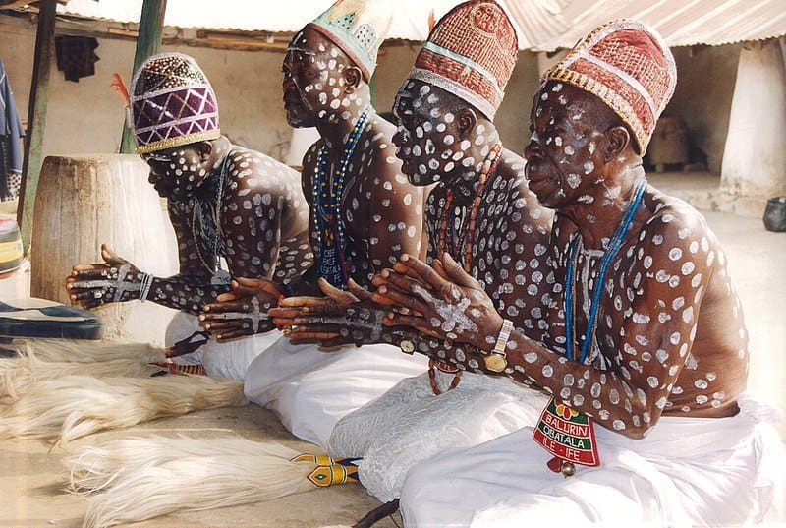
DW: 30 Unique African Traditional Religions That Will Blow Your Mind Posted by Diana K on October 15, 2023
Task:

Write an essay defending the lady’s brother
NB: For facilitations, call 0750025446/0784114269 (BAGUMA SSENTAMU RICHARD)

